**Analysis Documentation: Clinical and Demographic Insights**

**1. Demographic Overview**

The dataset comprises **211 participants**, analysed across multiple demographic and professional variables. Key findings include:

**Gender Distribution**

|  |  |  |  |  |  |
| --- | --- | --- | --- | --- | --- |
| **Gender** | | | | | |
|  | | Frequency | Percent | Valid Percent | Cumulative Percent |
| Valid | Female | 125 | 59.2% | 59.2% | 59.2% |
| Male | 86 | 40.8% | 40.8% | 100.0% |
| Total | 211 | 100.0% | 100.0% |  |

* **Female**: 59.2%
* **Male**: 40.8%

**Age Groups**

|  |  |  |  |  |  |
| --- | --- | --- | --- | --- | --- |
| **Age** | | | | | |
|  | | **Frequency** | **Percent** | **Valid Percent** | **Cumulative Percent** |
| Valid | 25-34 years | 90 | 42.7% | 42.7% | 42.7% |
| 35-47 years | 111 | 52.6% | 52.6% | 95.3% |
| Above 48 years | 10 | 4.7% | 4.7% | 100.0% |
| Total | 211 | 100.0% | 100.0% |  |

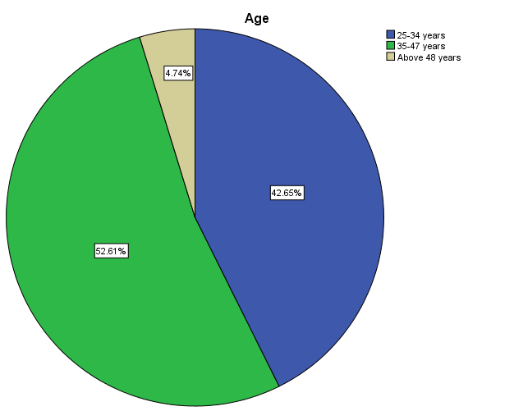

* **25–34 years**: 42.7%
* **35–47 years**: 52.6% (largest cohort)
* **Above 48 years**: 4.7%

|  |  |  |  |  |  |
| --- | --- | --- | --- | --- | --- |
| **Education Level** | | | | | |
|  | | **Frequency** | **Percent** | **Valid Percent** | **Cumulative Percent** |
| Valid | Postgraduate | 46 | 21.8% | 21.8% | 21.8% |
| Undergraduate | 165 | 78.2% | 78.2% | 100.0% |
| Total | 211 | 100.0% | 100.0% |  |

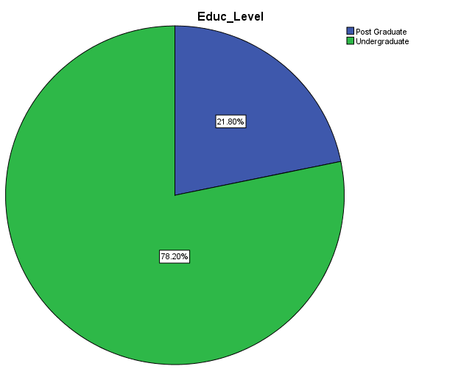

* **Undergraduate**: 78.2%
* **Postgraduate**: 21.8%

**ICT Proficiency**

|  |  |  |  |  |  |
| --- | --- | --- | --- | --- | --- |
|  | | | | | |
|  | | **Frequency** | **Percent** | **Valid Percent** | **Cumulative Percent** |
| Valid | Advanced | 92 | 43.6% | 43.6% | 43.6% |
| Basic | 66 | 31.3% | 31.3% | 74.9% |
| Intermediate | 53 | 25.1% | 25.1% | 100.0% |
| Total | 211 | 100.0% | 100.0% |  |

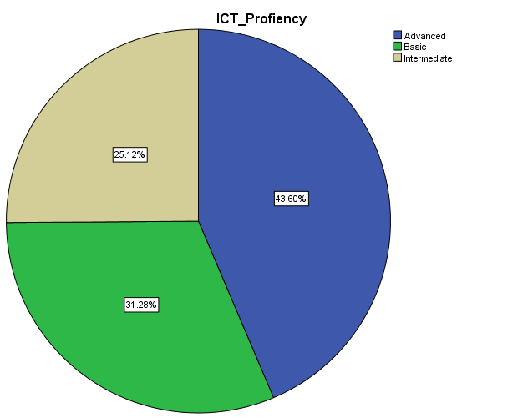

* **Advanced**: 43.6%
* **Basic**: 31.3%
* **Intermediate**: 25.1%

**Clinical Documentation Technology Usage**

|  |  |  |  |  |  |
| --- | --- | --- | --- | --- | --- |
|  | | | | | |
|  | | **Frequency** | **Percent** | **Valid Percent** | **Cumulative Percent** |
| Valid | EMR | 72 | 34.1% | 34.1% | 34.1% |
| Hybrid | 115 | 54.5% | 54.5% | 88.6% |
| Manual | 24 | 11.4% | 11.4% | 100.0% |
| Total | 211 | 100.0% | 100.0% |  |

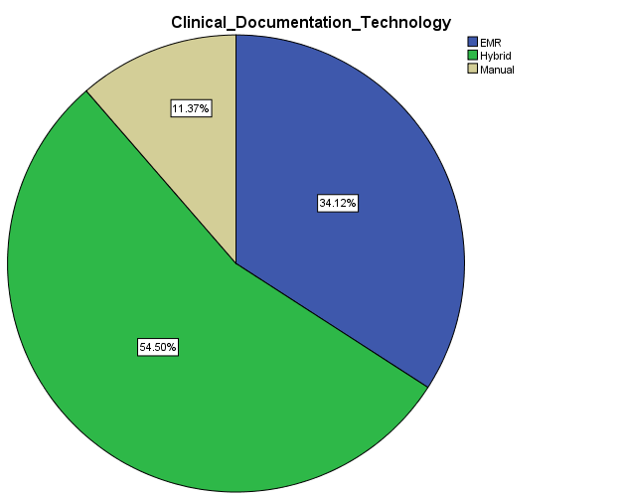

* **Hybrid Systems**: 54.5%
* **EMR (Electronic Medical Records)**: 34.1%
* **Manual Systems**: 11.4%

**2. Work Experience and Specialty**

|  |  |  |  |  |  |
| --- | --- | --- | --- | --- | --- |
| **Work Experience** | | | | | |
|  | | **Frequency** | **Percent** | **Valid Percent** | **Cumulative Percent** |
| Valid | 1-5 years | 29 | 13.7% | 13.7% | 13.7% |
| 10-15 years | 105 | 49.8% | 49.8% | 63.5% |
| 15-20 years | 26 | 12.3% | 12.3% | 75.8% |
| 20+ years | 26 | 12.3% | 12.3% | 88.2% |
| 5-10 years | 25 | 11.8% | 11.8% | 100.0% |
| Total | 211 | 100.0% | 100.0% |  |

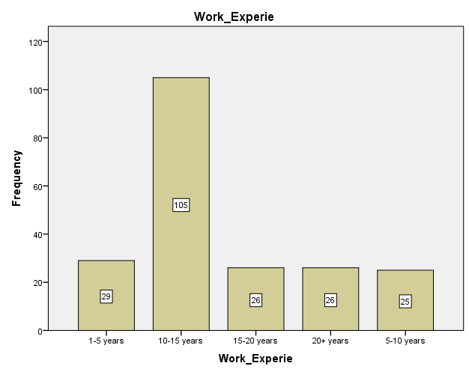

* **Work Experience**:
  + **10–15 years**: 49.8% (most common).
  + **20+ years** and **15–20 years**: 12.3% each.
* **Area of Specialty**:

|  |  |  |  |  |  |
| --- | --- | --- | --- | --- | --- |
| **Area specialty** | | | | | |
|  | | Frequency | Percent | Valid Percent | Cumulative Percent |
| Valid | Clinical Psychologist | 25 | 11.8% | 11.8% | 11.8% |
| Dentist | 4 | 1.9% | 1.9% | 13.7% |
| Dermatology | 6 | 2.8% | 2.8% | 16.6% |
| Gastrologist | 17 | 8.1% | 8.1% | 24.6% |
| General Physician | 31 | 14.7% | 14.7% | 39.3% |
| Gynaecologist | 12 | 5.7% | 5.7% | 45.0% |
| Medical Officer | 36 | 17.1% | 17.1%% | 62.1% |
| Neurologist | 6 | 2.8% | 2.8% | 64.9% |
| Obsgyn | 19 | 9.0% | 9.0% | 73.9% |
| Ophthalmologist | 10 | 4.7% | 4.7% | 78.7% |
| Orthopaedic | 17 | 8.1% | 8.1% | 86.7% |
| Paediatrician | 28 | 13.3%% | 13.3% | 100.0% |
| Total | 211 | 100.0% | 100.0% |  |

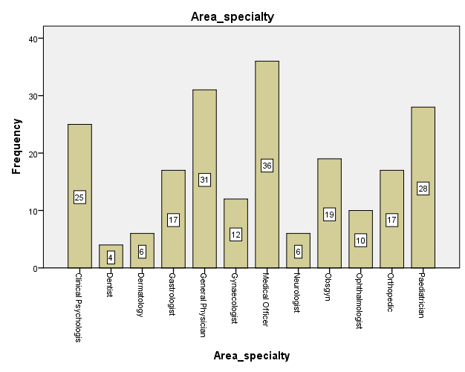

* + **Medical Officers**: 17.1% (largest group).
  + **General Physicians**: 14.7%, **Paediatricians**: 13.3%.

**Patient Interaction**

|  |  |  |  |  |  |
| --- | --- | --- | --- | --- | --- |
| **Frequency seeing Patients Inward** | | | | | |
|  | | **Frequency** | **Percent** | **Valid Percent** | **Cumulative Percent** |
| Valid | Never/ non | 20 | 9.5% | 9.5% | 9.5% |
| Once | 52 | 24.6% | 24.6% | 34.1% |
| Once-twice | 43 | 20.4% | 20.4% | 54.5% |
| Twice | 96 | 45.5% | 45.5% | 100.0% |
| Total | 211 | 100.0% | 100.0% |  |

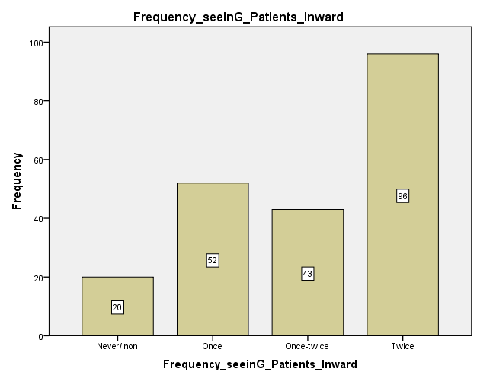

* **Frequency of Inward Patient Visits**:
  + **Twice**: 45.5% (most frequent).
* **Addressograph Completion**:

|  |  |  |  |  |  |
| --- | --- | --- | --- | --- | --- |
| **Fill patients addressograph** | | | | | |
|  | | Frequency | Percent | Valid Percent | Cumulative Percent |
| Valid | Always | 86 | 40.8% | 40.8% | 40.8% |
| Most of the times | 34 | 16.1% | 16.1% | 56.9% |
| Rarely | 42 | 19.9% | 19.9% | 76.8% |
| Sometimes | 49 | 23.2% | 23.2% | 100.0% |
| Total | 211 | 100.0% | 100.0%% |  |

* + **Always**: 40.8%, **Sometimes**: 23.2%.

**3. Compliance Analysis**

**Age and Compliance**

|  |  |  |  |  |
| --- | --- | --- | --- | --- |
| **Age * Age compliance binary Crosstabulation** | | | | |
|  | | | | |
|  | | **Age compliance binary** | | **Total** |
| **Compliant** | **Non-Compliant** |
| Age | 25-34 years | 15 | 75 | 90 |
| 35-47 years | 57 | 54 | 111 |
| Above 48 years | 2 | 8 | 10 |
| Total | | 74 | 137 | 211 |

|  |  |  |  |  |
| --- | --- | --- | --- | --- |
| **Chi-Square Tests** | | | | |
|  | **Value** | **df** | **Asymp. Sig. (2-sided)** | **Exact Sig. (2-sided)** |
| Pearson Chi-Square | 27.305a | 2 | .000 | **.000** |
| Likelihood Ratio | 28.501 | 2 | .000 | **.000** |
| Fisher’s Exact Test | 27.847 |  |  | **.000** |
| N of Valid Cases | 211 |  |  |  |
| 1. 1 cell (16.7%) have expected count less than 5. The minimum expected count is 3.51. | | | | |

* **Significant Association** (p=0.000):
  + **25–34 years**: 75 compliant vs. 15 non-compliant.
  + **35–47 years**: Higher non-compliance (57 non-compliant).

**Gender and Compliance**

|  |  |  |  |  |  |  |
| --- | --- | --- | --- | --- | --- | --- |
| **Case Processing Summary** | | | | | | |
|  | **Cases** | | | | | |
| **Valid** | | **Missing** | | **Total** | |
| **N** | **Percent** | **N** | **Percent** | **N** | **Percent** |
| **Gender * Gender Compliance binary** | **211** | **100.0%** | **0** | **0.0%** | **211** | **100.0%** |

|  |  |  |  |  |
| --- | --- | --- | --- | --- |
| **Gender * Gender Compliance binary Crosstabulation** | | | | |
|  | | | | |
|  | | **Gender Compliance binary** | | **Total** |
| **Compliant** | **Non-Compliant** |
| **Gender** | **Female** | **14** | **111** | **125** |
| **Male** | **23** | **63** | **86** |
| **Total** | | **37** | **174** | **211** |

|  |  |  |  |  |  |
| --- | --- | --- | --- | --- | --- |
| **Chi-Square Tests** | | | | | |
|  | **Value** | **df** | **Asymp. Sig. (2-sided)** | **Exact Sig. (2-sided)** | **Exact Sig. (1-sided)** |
| **Pearson Chi-Square** | **8.513a** | **1** | **.004** | **.005** | **.003** |
| **Continuity Correctionb** | **7.472** | **1** | **.006** |  |  |
| **Likelihood Ratio** | **8.376** | **1** | **.004** | **.005** | **.003** |
| **Fisher's Exact Test** |  |  |  | **.005** | **.003** |
| **N of Valid Cases** | **211** |  |  |  |  |
| a. 0 cells (0.0%) have expected count less than 5. The minimum expected count is 15.08. | | | | | |
| b. Computed only for a 2x2 table | | | | | |

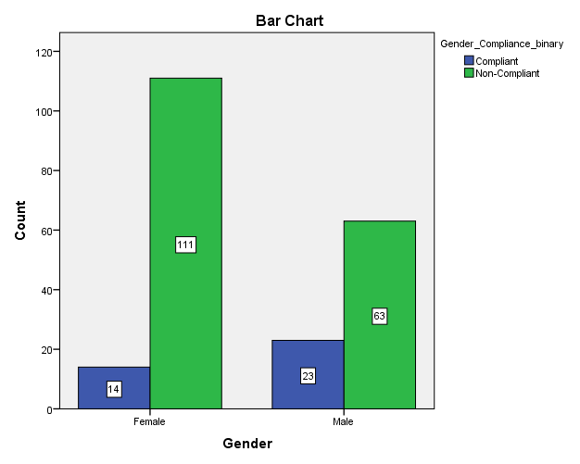

* **Females**: Higher compliance (111 compliant vs. 14 non-compliant; p=0.004).
* **Males**: 63 compliant vs. 23 non-compliant.

**Education Level and Compliance**

|  |  |  |  |  |  |  |
| --- | --- | --- | --- | --- | --- | --- |
| **Case Processing Summary** | | | | | | |
|  | **Cases** | | | | | |
| **Valid** | | **Missing** | | **Total** | |
| **N** | **Percent** | **N** | **Percent** | **N** | **Percent** |
| **Education Level * Education Compliance binary** | **211** | **100.0%** | **0** | **0.0%** | **211** | **100.0%** |

|  |  |  |  |  |
| --- | --- | --- | --- | --- |
| **Education Level * Education Compliance binary Crosstabulation** | | | | |
| **Count** | | | | |
|  | | **Education Compliance binary** | | **Total** |
| **Compliant** | **Non-Compliant** |
| Education Level | Postgraduate | 31 | 15 | 46 |
| Undergraduate | 98 | 67 | 165 |
| Total | | 129 | 82 | 211 |

|  |  |  |  |  |  |
| --- | --- | --- | --- | --- | --- |
| **Chi-Square Tests** | | | | | |
|  | **Value** | **df** | **Asymp. Sig. (2-sided)** | **Exact Sig. (2-sided)** | **Exact Sig. (1-sided)** |
| Pearson Chi-Square | .294a | 1 | .587 | .616 | .407 |
| Continuity Correctionb | .076 | 1 | .783 |  |  |
| Likelihood Ratio | .309 | 1 | .579 | .616 | .407 |
| Fisher's Exact Test |  |  |  | .790 | .407 |
| N of Valid Cases | 211 |  |  |  |  |
| a. 0 cells (0.0%) have expected count less than 5. The minimum expected count is 5.01. | | | | | |
| b. Computed only for a 2x2 table | | | | | |

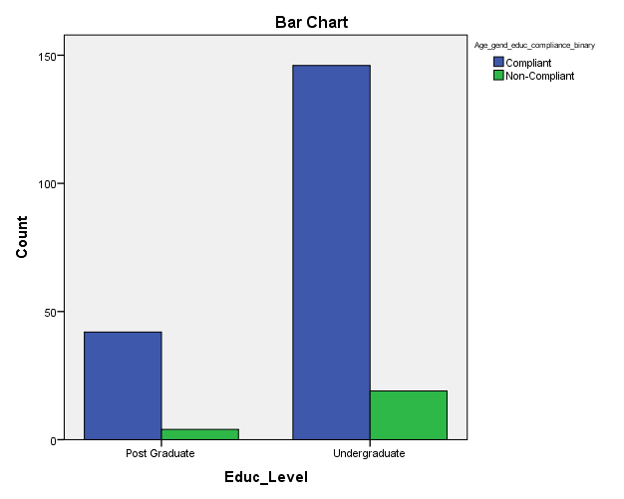

* **No Significant Association** (p=0.587):
  + Postgraduates: 67.4% compliant vs. 32.6% non-compliant.
  + Undergraduates: 59.4% compliant vs. 40.6% non-compliant.

**Work Experience and Compliance**

|  |  |  |  |  |  |  |
| --- | --- | --- | --- | --- | --- | --- |
| **Case Processing Summary** | | | | | | |
|  | **Cases** | | | | | |
| **Valid** | | **Missing** | | **Total** | |
| **N** | **Percent** | **N** | **Percent** | **N** | **Percent** |
| Work Experience * Work experience Compliance binary | 211 | 100.0% | 0 | 0.0% | 211 | 100.0% |

|  |  |  |  |  |
| --- | --- | --- | --- | --- |
| **Work Experience * Work experience Compliance binary Crosstabulation** | | | | |
|  | | | | |
|  | | **Work experience Compliance binary** | | **Total** |
| **Compliant** | **Non-Compliant** |
| Work Experience | 1-5 years | 25 | 4 | 29 |
| 10-15 years | 88 | 17 | 105 |
| 15-20 years | 26 | 0 | 26 |
| 20+ years | 26 | 0 | 26 |
| 5-10 years | 25 | 0 | 25 |
| Total | | 190 | 21 | 211 |

|  |  |  |  |  |
| --- | --- | --- | --- | --- |
| **Chi-Square Tests** | | | | |
|  | **Value** | **df** | **Asymp. Sig. (2-sided)** | **Exact Sig. (2-sided)** |
| Pearson Chi-Square | 13.547a | 4 | .009 | .009 |
| Likelihood Ratio | 20.485 | 4 | .000 | .000 |
| Fisher's Exact Test | 13.215 |  |  | .005 |
| N of Valid Cases | 211 |  |  |  |
| a. 4 cells (40.0%) have expected count less than 5. The minimum expected count is 2.49. | | | | |

* **Significant Association** (p=0.009):
  + **10–15 years**: 88 compliant vs. 17 non-compliant (highest compliance).
  + **20+ years**: All 26 compliant.

**4. Knowledge Assessment**

**Gender and Knowledge Rating**

* **Males**: Higher "Excellent" ratings (64 vs. 59 females).
* **Females**: Higher "Good" ratings (53 vs. 22 males).
* **Significant Association** (p=0.000).

**Age and Knowledge Rating**

* **35–47 years**: 71 "Excellent" ratings (highest).
* **25–34 years**: 46 "Good" ratings.
* **Significant Association** (p=0.000).

**ICT Proficiency and Knowledge Rating**

* **Advanced Proficiency**: 64 "Excellent" ratings.
* **Intermediate Proficiency**: 43 "Good" ratings.
* **Strong Association** (p=0.000).

**Documentation Technology and Knowledge Rating**

* **Hybrid Users**: 69 "Excellent" ratings.
* **Manual Users**: Majority "Fair" ratings (13/24).
* **Significant Association** (p=0.000).

**5. Key Conclusions**

1. **Demographics**: The cohort is predominantly female, middle-aged (35–47 years), and undergraduate-educated. Hybrid systems dominate clinical documentation.
2. **Compliance**: Younger participants (25–34 years) and females exhibit higher compliance. Work experience (10–15 years) correlates with better compliance.
3. **Knowledge**: Males and those with advanced ICT proficiency score higher in "Excellent" knowledge ratings. Hybrid technology users demonstrate superior knowledge outcomes.
4. **Associations**: Age, gender, ICT proficiency, and documentation technology significantly influence compliance and knowledge (p<0.05).

**6. Limitations**

* Small cell sizes in some chi-square tests (e.g., "Above 48 years" age group) may affect reliability.
* Specialty-specific analyses (e.g., Dentists, Dermatologists) lack statistical power due to low frequencies.

**7. Recommendations**

* **Training Programs**: Target males and older age groups to improve compliance.
* **Technology Adoption**: Encourage Hybrid/EMR systems to enhance knowledge and efficiency.
* **Further Research**: Expand sample size for underrepresented groups (e.g., older professionals, niche specialties).